**Supplementary Appendix 3**. Coverage-based rarefaction and extrapolation curves for South Africa at the a) the national, b) provincial and c) municipal scales. The shaded areas represent 95% confidence intervals obtained by the bootstrap method based on 50 replications.

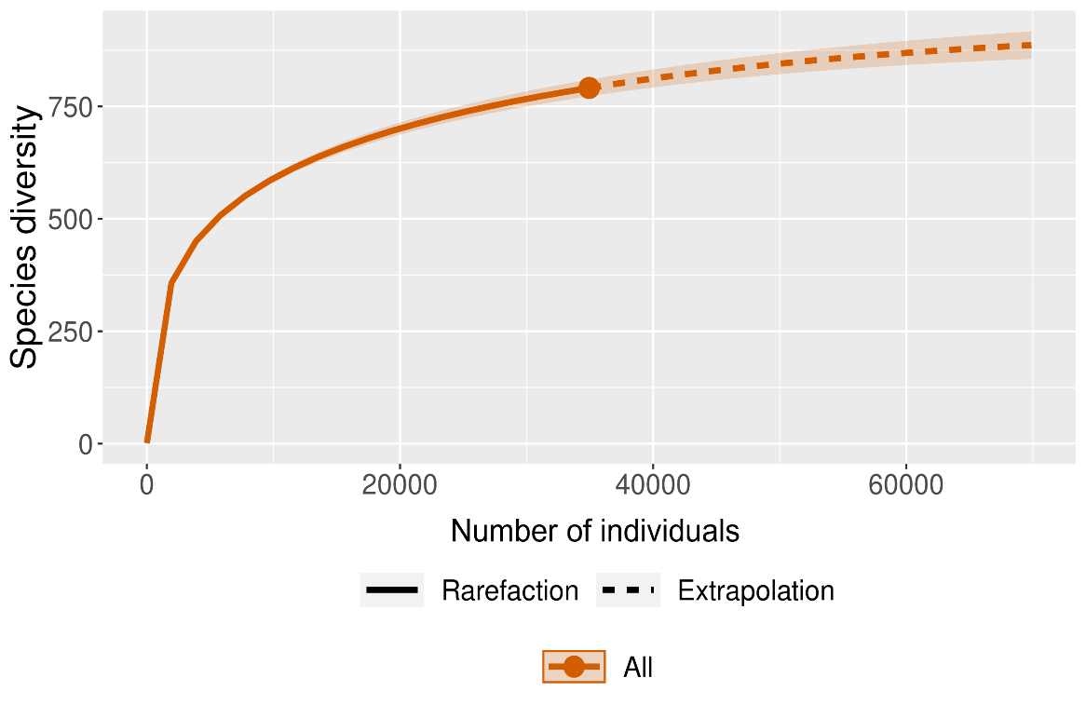

a)

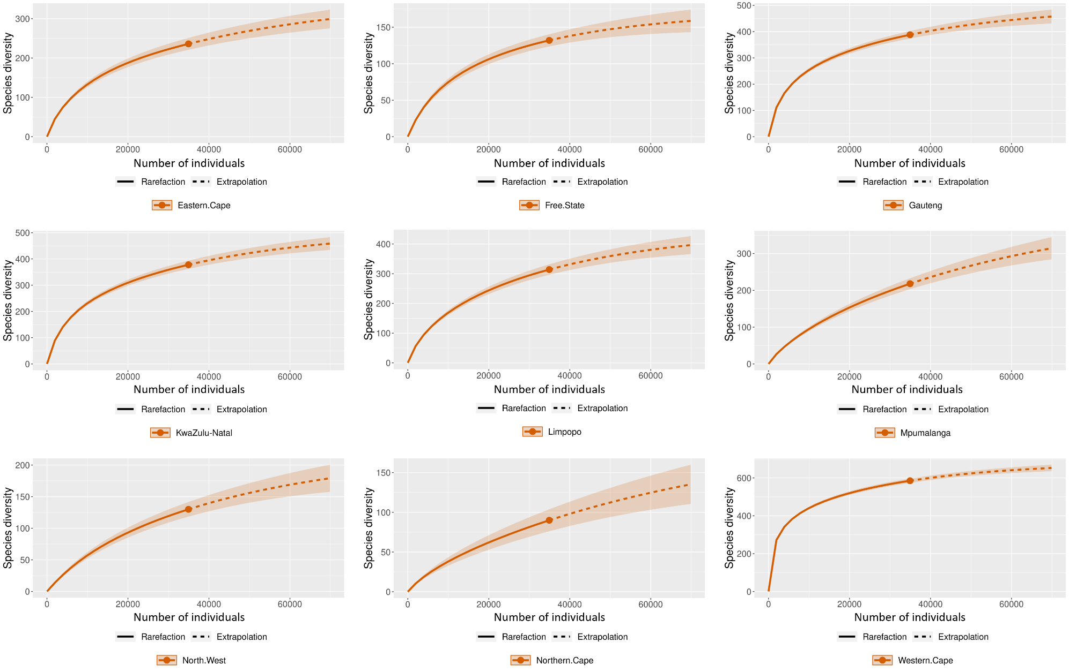

b)

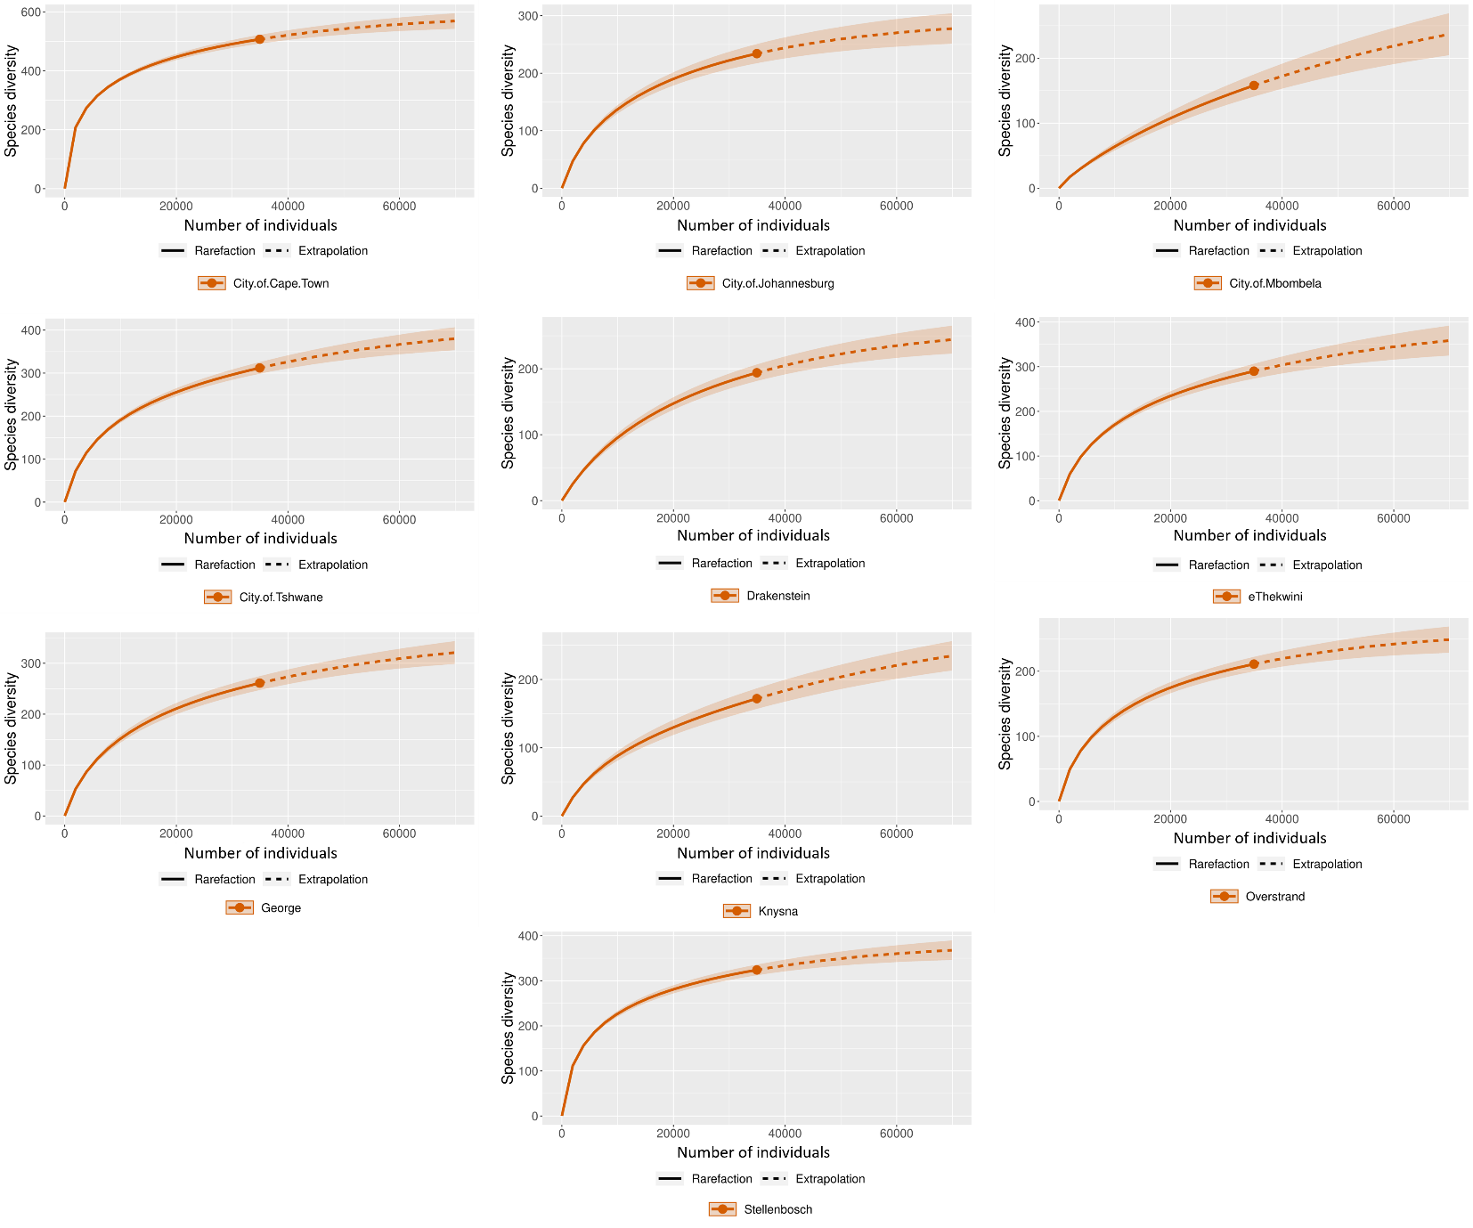

c)